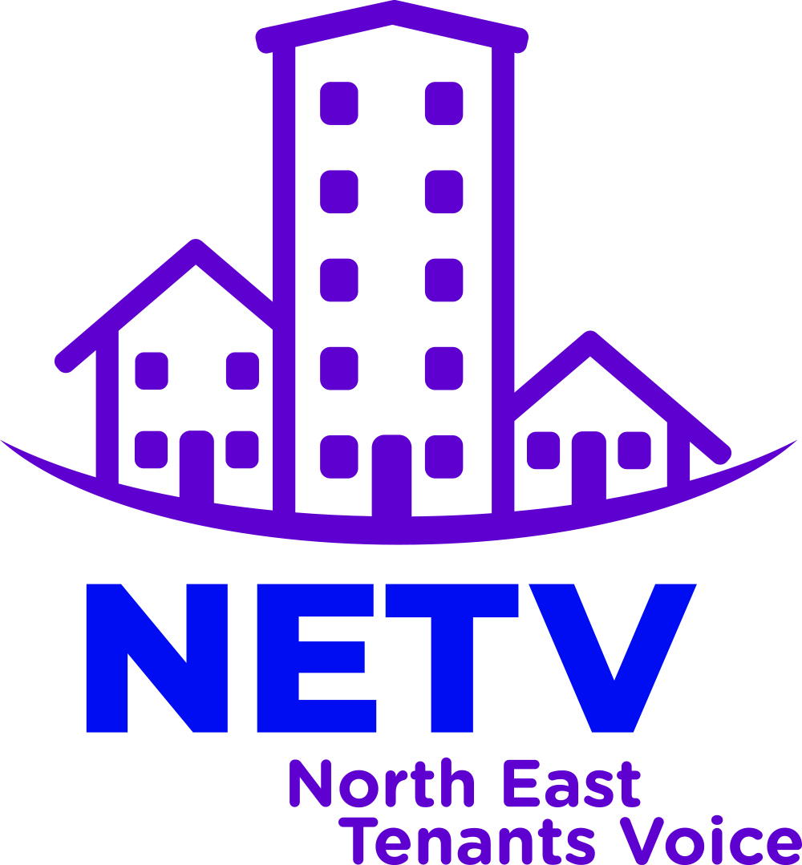

Net Zero Carbon Agenda Briefing

North East Tenants Voice
Introduction
Tpas has facilitated the creation of four specialist groups as sub-groups to the collective North East Tenants Voice to explore four key priority areas using the following three questions as a basis to form their response:
- What current action is being taken on this key priority?
- What resources can be accessed or what areas of the sector can help raise the profile of this priority?
- What role could NETV have in responding to the key priority locally, regionally and nationally?

This briefing paper comprises of the findings produced by the ‘Net Zero Carbon Agenda’ specialist sub-group.

- What current action is being taken on this key priority?
The Net Zero Carbon Agenda is a vast subject that requires exploration and action on many levels.
It is felt that this agenda needs to be focussed on long term by the North East Tenants Voice and it is important that we all understand our own Carbon Footprint before we can begin to tackle it as a wider national and global issue.
- What resources can be accessed or what areas of the sector can help raise the profile of this priority?

To enable us to all understand our own Carbon Footprint, this specialist group has made the recommendation to all NETV members to use the online tool ‘WWF Footprint calculator’.
Here are a few simple steps we can all take to reduce our own personal carbon footprint:
- Make sure to recycle.
- Switch to low energy light bulbs
- Obtain smart meters
- Use public transport if possible instead of car
- Stop using one use bags for shopping
- Turn off lights when leaving room and don't leave equipment on standby

- What role could NETV have in responding to the key priority locally, regionally and nationally? Key recommendations:

After we all have an understanding of our own carbon footprint and ways we can reduce it, the NETV can competently encourage our housing providers to obtain there carbon footprint and provide an action plan in tackling and reducing their carbon footprint.
This specialist group sees the one of the main priorities for housing providers is to switch to the use of electric vehicles, especially relating to maintenance divisions.

